2235. Add Two Integers

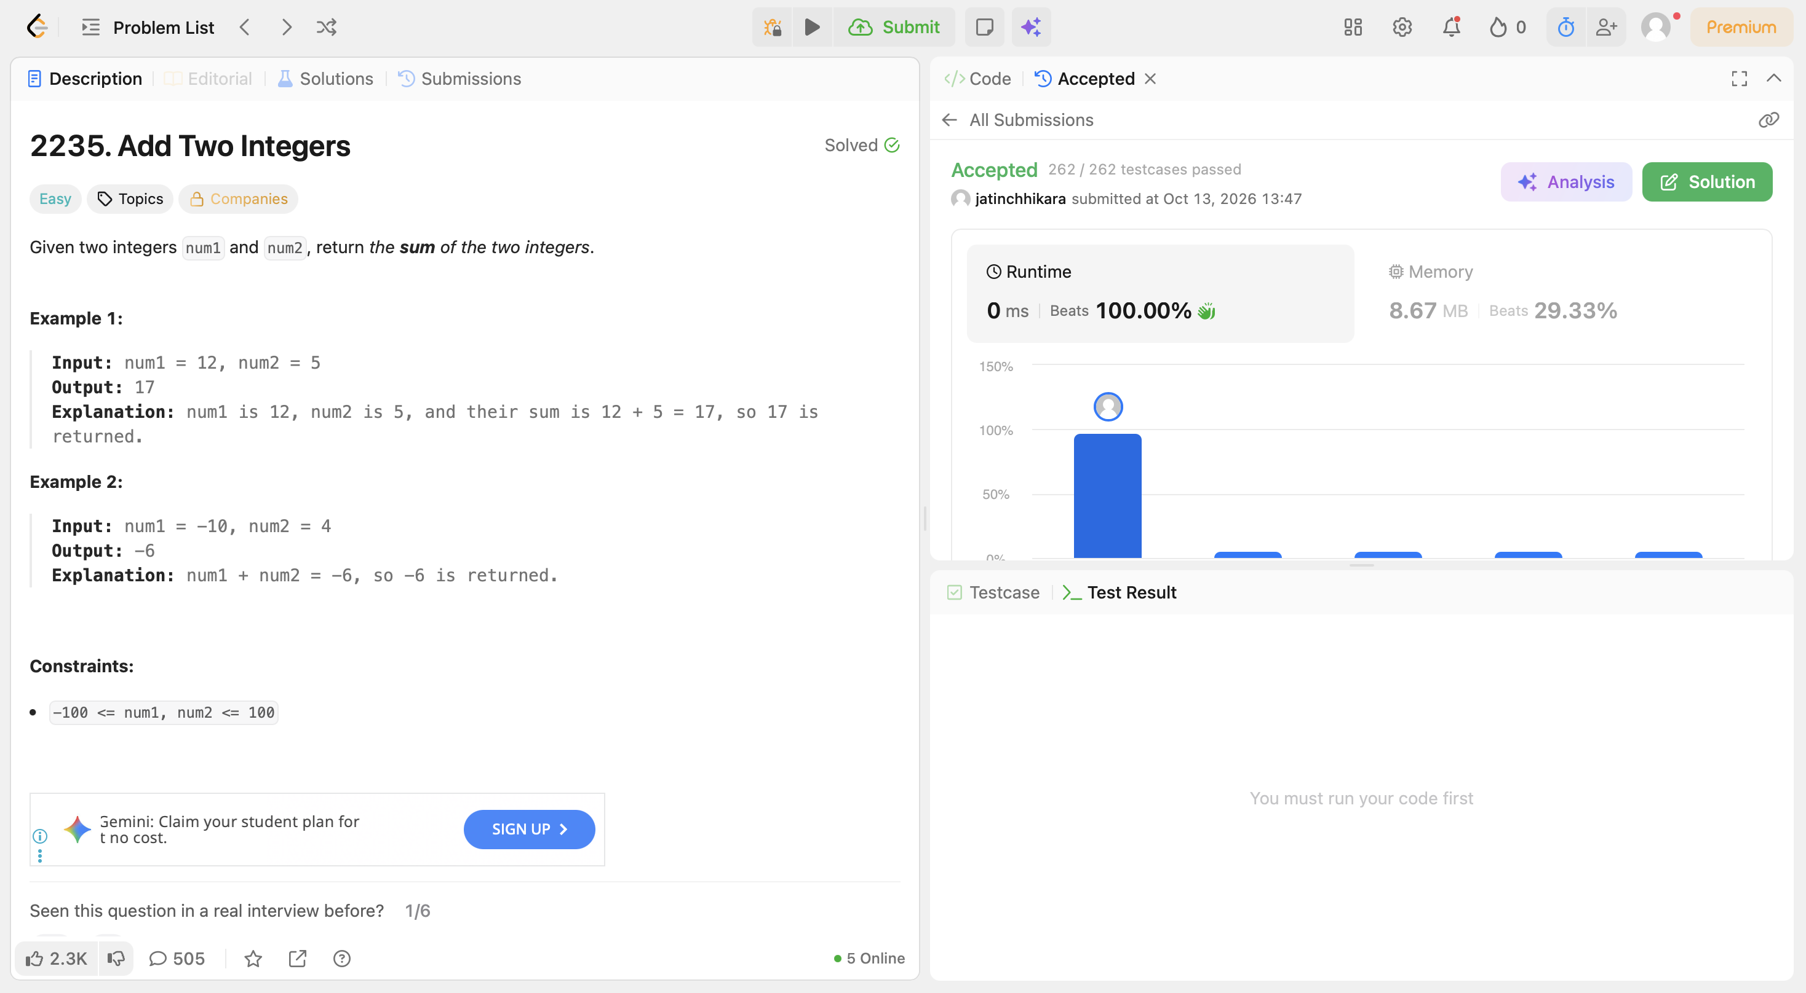
Code:
int sum(int num1, int num2) {
return num1+num2;
}

